Write a composition of at least 150 words about being considerate.

The Pictures are provided to help you think about this topic.

Your composition should be based on one or more of these pictures.

Consider the following points when you plan your composition:

- How were you being considerate?
- What effect did your consideration have?

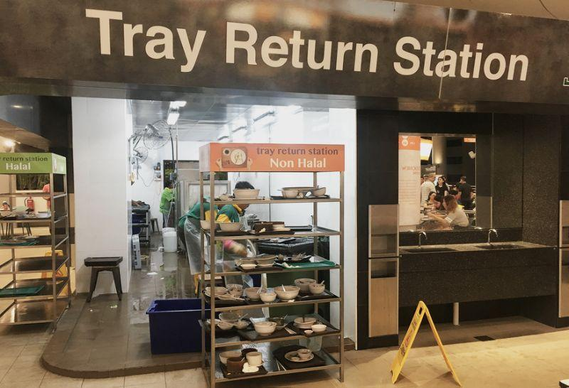

You may use the points in any order and include other relevant points as well.
Being Considerate – Picture ( Tray Return Station)
“Molly! Quick! I found us some seats!” screeched Alina. I made a beeline towards her and quickly settled down on to my seat. We both smiled in relief thanking our lucky stars that we managed to get two seats in the crowded food court during lunch time. My stomach grumbled loudly causing Alina to stare at me. I gave her a sheepish smile before heading towards the noodle stall. I joined the snaking queue and eventually bought my food.
Alina and I wolfed down our food. We both were so famished that we did not even talk with one another. Only after completing our meals did we start chatting. Ten minutes into our conversation, I saw an elderly lady wearing green apron approach a nearby table. She was moving slowly as she began clearing the trays that had been left behind by the other patrons. She carried the trays in her shaky hands and headed towards the tray return station. I craned my neck and noticed that the person cleaning the tray and restacking them was also the same elderly. As I looked around, I realised that many people were oblivious to the plight of the elderly cleaner who was working in the food court at this old age. Despite having the tray return station in plain sight, many individuals would just leave their trays at their tables after eating and walk off. My heart sank at the sight of the tired old lady having to make multiple trips to clear the trays left behind and clean them as well.
I excused myself from Alina and began collecting trays that had been left behind and brought them to the tray return station. Initially the elderly woman looked very puzzled as she was confused so as to why I was holding a few trays and returning the trays multiple times. Soon she realised that I was being considerate and broke into a wide grin. I smiled too as I could see how happy the elderly lady was by my simple action. As I helped her collect more trays, she managed to get more cleaning done and she had a look of satisfaction on her face. She thanked me profusely and I felt contented as I realised the impact I had made by simply being considerate.

